* **MULTIPLY BY A CONSTANT**
  + We can multiply a matrix by a **constant** *(the value 2 in this case)*:

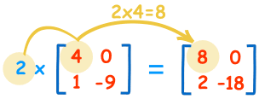

These are the calculations:

|  |  |
| --- | --- |
| 2×4=8 | 2×0=0 |
| 2×1=2 | 2×−9=−18 |

* We call the constant a **scalar**, so officially this is called "scalar multiplication".

## MULTIPLYING A MATRIX BY ANOTHER MATRIX

* But to multiply a matrix **by another matrix** we need to do the "[**dot product**](https://www.mathsisfun.com/algebra/vectors-dot-product.html)" of rows and columns ... what does that mean? Let us see with an example:
* To work out the answer for the **1st row** and **1st column**:

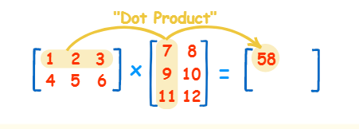

* The "Dot Product" is where we **multiply matching members**, then sum up:
* (1, 2, 3) • (7, 9, 11) = 1×7 + 2×9 + 3×11= 58
* We match the 1st members (1 and 7), multiply them, likewise for the 2nd members (2 and 9) and the 3rd members (3 and 11), and finally sum them up.
* Want to see another example? Here it is for the 1st row and **2nd column**:

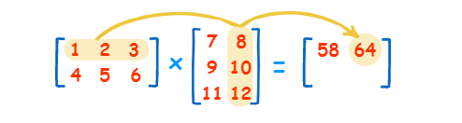

* + (1, 2, 3) • (8, 10, 12) = 1×8 + 2×10 + 3×12 = 64
* We can do the same thing for the **2nd row** and **1st column**:

(4, 5, 6) • (7, 9, 11) = 4×7 + 5×9 + 6×11 = 139

* And for the **2nd row** and **2nd column**:

(4, 5, 6) • (8, 10, 12) = 4×8 + 5×10 + 6×12 = 154

* And we get:

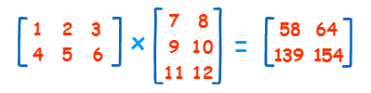

DONE!

## Why Do It This Way?

* This may seem an odd and complicated way of multiplying, but it is necessary!
* I can give you a real-life example to illustrate why we multiply matrices in this way.

### Example: The local shop sells 3 types of pies.

* Apple pies cost **$3** each
* Cherry pies cost **$4** each
* Blueberry pies cost **$2** each
* And this is how many they sold in 4 days:

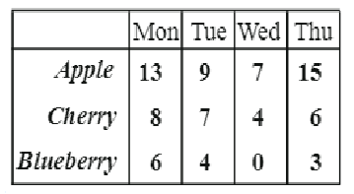

* Now think about this ... the **value of sales** for Monday is calculated this way:
* Apple pie value + Cherry pie value + Blueberry pie value

$3 × 13 + $4 × 8 + $2 × 6 = $83

* So it is, in fact, the "dot product" of prices and how many were sold:



* We **match** the price to how many sold, **multiply** each, and then **sum** the result.
* In other words:
* The sales for Monday were: Apple pies: **$3×13=$39**, Cherry pies: **$4×8=$32**, and Blueberry pies: **$2×6=$12**. Together that is $39 + $32 + $12 = **$83**
* And for Tuesday: **$3×9 + $4×7 + $2×4 = $63**
* And for Wednesday: **$3×7 + $4×4 + $2×0 = $37**
* And for Thursday: **$3×15 + $4×6 + $2×3 = $75**
* So it is important to match each price to each quantity.
* Now you know why we use the "dot product".
* And here is the full result in Matrix form:

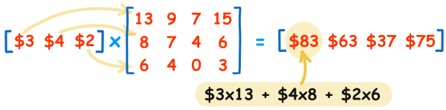

* They sold **$83** worth of pies on Monday, **$63** on Tuesday, etc. (You can put those values into the [**Matrix Calculator**](https://www.mathsisfun.com/algebra/matrix-calculator.html) to see if they work.)

## Rows and Columns

* To show how many rows and columns a matrix has we often write **rows×columns**.
* Example: This matrix is **2×3** (2 rows by 3 columns):

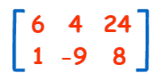

* When we do multiplication:
* The number of **columns of the 1st matrix** must equal the number of **rows of the 2nd matrix**.
* And the result will have the same number of **rows as the 1st matrix**, and the same number of **columns as the 2nd matrix**.

### Example:



* In that example we multiplied a 1×3 matrix by a 3×4 matrix (note the 3s are the same), and the result was a 1×4 matrix.
* *In General:*

To multiply an **m×n** matrix by an **n×p** matrix, the **n**s must be the same, and the result is an **m×p** matrix.

matrix multiply rows cols

* So ... multiplying a **1×3** by a **3×1** gets a **1×1** result:

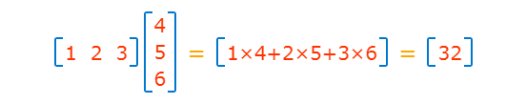

* But multiplying a **3×1** by a **1×3** gets a **3×3** result:

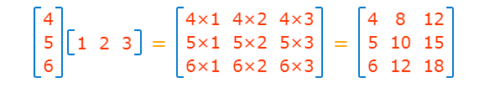

## IDENTITY MATRIX

* The "Identity Matrix" is the matrix equivalent of the number "1":

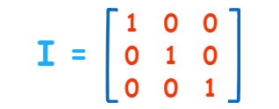

* A 3×3 Identity Matrix
* It is "square" (has same number of rows as columns)
* It can be large or small (2×2, 100×100, ... whatever)
* It has **1**s on the main diagonal and **0**s everywhere else
* Its symbol is the capital letter **I**
* It is a **special matrix**, because when we multiply by it, the original is unchanged:

A × I = A

I × A = A

## Order of Multiplication

* In arithmetic we are used to:

3 × 5 = 5 × 3  
(The [Commutative Law](https://www.mathsisfun.com/associative-commutative-distributive.html) of Multiplication)

* But this is **not** generally true for matrices (matrix multiplication is **not commutative**):

AB ≠ BA

* When we change the order of multiplication, the answer is (usually) **different**.

### Example:

* + See how changing the order affects this multiplication:

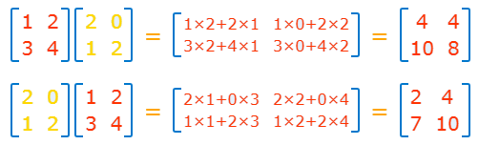

* + The answers are different!
* It can have the same result (such as when one matrix is the Identity Matrix) but not usually.